# Open Raster With Style Override

This tool allows the user to open one or more raster files into a map and apply a predefined raster override style. Especially, the ability to make the raster transparent for a given color can be useful.

The tool allows you to control where the ***Open Raster button*** appears on the ***Home***, ***Map***, and ***Table tab***, see the chapter **Configuration File**.

The tool also allows you to translate some of the texts seen, see the chapter **Translation**. Errors will still be in English.

## Open Raster Files

Click on one of the ***Open Raster controls*** on either the ***Home***, ***Map*** or ***Table tab***.

Select one or more tables from the dialog and hit ***OK***.

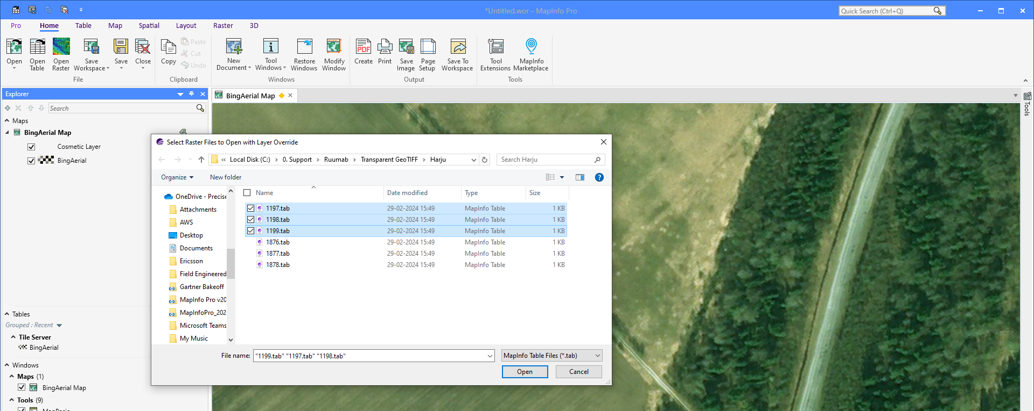

The selected tables will now be opened.

If a map window exists, the tables will be added to this and for each layer, the layer settings will be applied.

If no map window exists, a new map window will be opened using the first table and the remaining tables will be added to this map as well. The layer settings will also be applied to all the layers in this case.

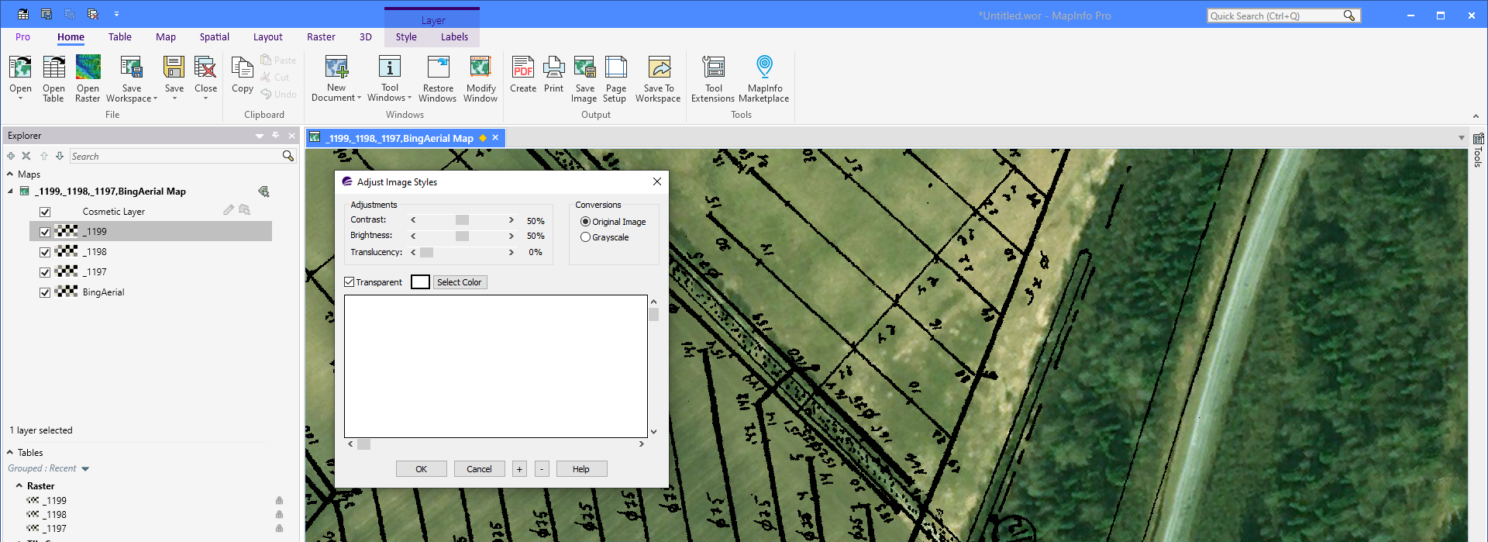

## Reading Raster Layer Settings

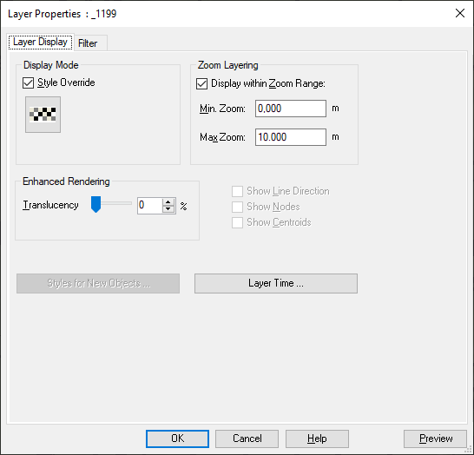This is how you configure the raster layer and store the setting to be used with the tool.

In the configuration file, you have to enable the setting that adds the Read Raster Layer Setting to the Layer Context menu in the Layer List. You do this by setting the key AddReadLayerSetting in the [Ribbon] section to T.

Now start the tool and open one of the raster tables.

Using the ***Layer Properties dialog***, you specify how you want the layer to look and behave.

You can enable the ***Zoom Layering*** so that the raster only is visible in a given range.

And you can use the ***Style Override*** to make the layer transparent for a given color.

When done, click the ***OK button*** to apply these settings on the layer.

Now right-click on the layer and select ***Read Raster Layer Settings*** from the Layer context menu.

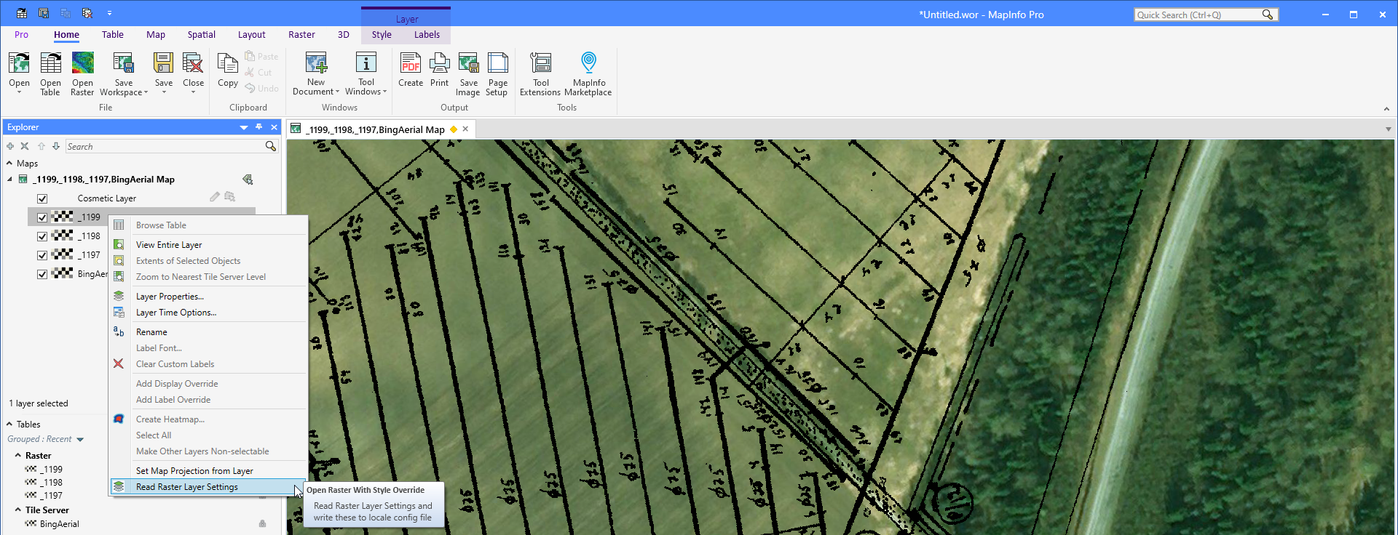

This will read the layer settings and write these to the configuration file.

There is however an issue reading the transparency of the layer. If you want to make the layer transparent for a given color, you will have to modify the configuration file manually for these values, see the chapter ***Configuration File***.

## Configuration File

The configuration file can help you control some of the behaviour of the tool.

The [Ribbon] sections allows you to control where you want the buttons placed on the ribbon. You can place a button on each of these tabs: Home (TabHome), Table (TabTable), and Map (TabMap). If you set the AddTo_ key to 1, the button will be added. If you set the value to 0, no button will be placed on the specified tab.

Make sure you at least place a button on one of the tabs.

You can also control where to place the button on each tab.

The default is to specify a control you want to add the button after. This is done via the AddAfterControl_ key. This is really not for all users to change as you need to know the names of the controls. Here are some typical controls you could place the button after.

Note that the button can only be placed in the first tab group on each tab.

|  |  |  |
| --- | --- | --- |
| **Icon** | **Tab** | **Control Name** |
|  | Home | HomeFileOpenGallerySplitButton |
|  | Home | OpenTableButton |
|  | Home | HomeSaveWorkspaceSplitButton |
|  | Home | HomeSaveSplitButton |
|  | Home | CloseSplitButton |
|  | Table | NewBrowserButton |
|  | Table | TableFileOpenGallerySplitButton |
|  | Map | NewMapButton |
|  | Map | MapFileOpenGallerySplitButton |
|  | Map | MapAddThematicButton |
|  | Map | AddToMapSplitButton |
|  | Map | CosmeticSplitButton |

If you want to use a position instead, make sure the AddAfterControl_ key is set to an empty string by removing any values after =.

You can either specify a position as a number using the AddAtPosition_ keys. If you specify 0, the button will be placed as the first button. If you specify 1 , it will be the second button. Make sure the AddAfterControl for the specific tab refers to an empty string. If you specify -1, the button will be added at the end of the ribbon group.

The final key in the [Ribbon] section AddReadLayerSetting controls if you want to add a control to the Layer List allowing the user to read the layer setting from a layer and write it to the configuration file. The recommended option is to set this to 0.

[RIBBON]

ADDTO_TabHome=1

ADDTO_TabMap=1

ADDTO_TabTable=1

ADDATPOSITION_TabHome=0

ADDATPOSITION_TabMap=0

ADDATPOSITION_TabTable=0

ADDAFTERCONTROL_TabHome=OpenTableButton

ADDAFTERCONTROL_TabMap=MapFileOpenGallerySplitButton

ADDAFTERCONTROL_TabTable=TableFileOpenGallerySplitButton

ADDREADLAYERSETTING=0

In the [Data] section you can configure the default folder that the user will be prompted to open tables from.

[DATA]

FOLDER=C:\Data\Raster Plans\GeoTIFF\

And finally in the [Layer] section, you will find the LayerSettings key. This holds details about the settings that will be applied to the raster table after adding it to the map. The string is written to the configuration file via the Read Layer Setting control. Many of the values will be ignored for raster layers.

[LAYER]

LAYERSETTINGS=F;F;F;4.8;1900;m;2;F;F;F;255;2,2,16728064;2,2,16728064;1,16777215,16777215;Precision Sans W,0,10,0,-1;2,35,16744448,4,MapInfo Symbols,256,0;T;16777215

This are what the variables refer to for the layer:

1. Editable (T/F)
2. Selectable (T/F)
3. Zoom Layered (T/F)
4. Min Zoom
5. Max Zoom
6. Zoom Distance Units
7. Display Type
   * 0: Off
   * 1: Graphic
   * 2: Global
   * 3: Value/Theme
8. Show Line Direction (T/F)
9. Show Nodes (T/F)
10. Show Centroid (T/F)
11. Alpha Factor (0-255, 0: Fully Transparent, 255: Fully Opaque)
12. Pen Override, 3 comma separated values
13. Border Pen Override, 3 comma separated values
14. Brush Override, 3 comma separated values
15. Text Font Override, 5 comma separated values
16. Symbol Override, 4-7 comma separated values
17. Raster Transparency (T/F)
18. Raster Transparency Color (0-16777215)

The last two parameters are not read from the layers. You will have to change these manually if you want the raster layer to be transparent for a given color. Set the first value to T and the second to the transparent color where 0 is black and 16777215 is white.

## Translation

The file OpenRasterWithStyleOverride.str contains several strings that make up most of the interface of the tool. The file can be translated to other languages if needed. Keep in mind that the file needs to use UTF-8 when you make edits to it.

This is the content of the file:

[STRINGS]

1="Open Raster"

2="Select one or more Raster Files to open with Layer Override settings"

3="Select Raster Files to Open with Layer Override"

4="Read Raster Layer Settings"

5="Read Raster Layer Settings and write these to locale config file"

Where:

1. The caption on the Open Raster button on the ribbon
2. The help message for the Open Raster button
3. The title of the Open Raster dialog
4. The caption on the Read Raster Layer Settings control in the Layer context menu
5. The help message for the Read Raster Layer Settings control in the Layer context menu

If you make changes to the file, save the changes back to the file and restart the tool. The file is read when the tool is loaded into MapInfo Pro.

## Icons

Open Raster with Style Override uses the image file Raster_32.png in the application folder for the buttons on the ribbon.

By default, this button will look like this:



You can however change the icon to a black/white icon instead by renaming the file RasterBW_32.png to RasterBW.png. In this way, the tool will use the black/white icon instead.

